Managed Key in AWS KMS
Tasks
1.
Log in to your AWS account and use AWS Key Management Service (KMS) to create a new symmetric customer managed key named 'FoodieAppKey' for encrypting Zomato-style order data. Note down the key ARN and set an alias for easy identification.
2.
In AWS KMS, enable automatic key rotation for the 'FoodieAppKey' you created. Take a screenshot of the rotation status showing it is enabled.
3.
Write a short note comparing how key rotation is handled in AWS KMS versus Azure Key Vault. Mention at least two similarities and two differences.
4.
Use AWS KMS to generate a data encryption key (DEK) with the 'FoodieAppKey', then encrypt a sample order string (e.g., 'OrderID: 12345, Item: Pizza') using the DEK. Show both the encrypted and decrypted outputs.<br><br><em><strong>Hint:</strong> You can use the AWS CLI or AWS SDK for this task.</em>
5.
Use ChatGPT to draft a sample key rotation policy for a Flipkart-style e-commerce app, specifying rotation frequency, notification process, and steps to handle compromised keys. Paste the generated policy and highlight any changes you would make for your own app.

Answer : Task 1: Create a Symmetric Customer Managed Key in AWS KMS
What is AWS KMS?
AWS Key Management Service (KMS) is a service that lets you create and manage encryption keys to protect your data.
Steps
Step 1: Login to AWS
- Open AWS Console.
- Sign in to your AWS account.
Step 2: Open KMS
- In the search bar, type KMS.
- Click Key Management Service (KMS).
Step 3: Create a Key
- Click Customer managed keys.
- Click Create key.
Step 4: Configure the Key
Choose:
- Key type: Symmetric
- Key usage: Encrypt and decrypt
Click Next.
Step 5: Give the Key a Name
Key name:
FoodieAppKey
(Optional)
Description:
Encryption key for Foodie App order data
Click Next.
Step 6: Choose Administrators
Select your IAM user (or administrator account).
Click Next.
Step 7: Choose Users
Select the users who can use this key.
Click Next.
Step 8: Review and Create
Click Finish.

Find the Key ARN
Open the key.
You'll see something like:
ARN:
arn:aws:kms:us-east-1:123456789012:key/abcd1234-5678-90ef-ghij-klmnopqrstuv
Save this ARN.

Create an Alias
Inside the key page
Click
Aliases
Then
Create Alias
Example:
alias/FoodieAppKey
Save it.

Task 2: Enable Automatic Key Rotation
What is Key Rotation?
Key rotation means AWS automatically creates new cryptographic key material every year while keeping the same key ID. This improves security.
Steps
Open
AWS KMS
↓
Customer Managed Keys
↓
Select
FoodieAppKey
↓
Go to
Key Rotation
↓
Click
Edit
↓
Enable
Automatic Key Rotation
↓
Save Changes.

Screenshot
Take a screenshot showing:
Automatic Key Rotation

✓ Enabled
Use this screenshot in your report.

Task 3: AWS KMS vs Azure Key Vault

Similarities
- Both securely store encryption keys.
- Both support automatic key rotation.

Differences
AWS KMS | Azure Key Vault
Rotation is enabled with one setting for supported keys. | Rotation uses configurable rotation policies.
Works mainly with AWS services. | Integrates with Azure services.

Short Note
AWS KMS and Azure Key Vault are cloud services used for managing encryption keys securely. Both support automatic key rotation and integrate with cloud resources to protect sensitive data. However, AWS KMS enables annual automatic rotation for supported customer-managed symmetric keys with a simple setting, while Azure Key Vault provides configurable rotation policies that allow more flexibility in scheduling. AWS KMS is designed for the AWS ecosystem, whereas Azure Key Vault is designed for Microsoft Azure services.

Task 4: Generate a Data Encryption Key (DEK)
What is a DEK?
A Data Encryption Key (DEK) encrypts your actual data. The DEK itself is protected (encrypted) by your KMS key.

Generate DEK Using AWS CLI
Replace the key ID with your own key ARN or alias.
aws kms generate-data-key \
--key-id alias/FoodieAppKey \
--key-spec AES_256
Example output:
{
"CiphertextBlob": "AQICAHj....",
"Plaintext": "P5Z2xVQj7K6....",
"KeyId": "arn:aws:kms:us-east-1:123456789012:key/..."
}
- Plaintext → use it to encrypt your data.
- CiphertextBlob → save it so you can decrypt the DEK later.

Python Example (Encrypt & Decrypt)
Install the required package:
pip install boto3 cryptography
import boto3
from cryptography.fernet import Fernet
import base64

kms = boto3.client("kms")

response = kms.generate_data_key(
KeyId="alias/FoodieAppKey",
KeySpec="AES_256"
)

plaintext_key = response["Plaintext"]
encrypted_key = response["CiphertextBlob"]

fernet_key = base64.urlsafe_b64encode(plaintext_key[:32])

cipher = Fernet(fernet_key)

message = b"OrderID: 12345, Item: Pizza"

encrypted = cipher.encrypt(message)

decrypted = cipher.decrypt(encrypted)

print("Encrypted Data:")
print(encrypted)

print("\nDecrypted Data:")
print(decrypted.decode())

Example Output
Encrypted Data

gAAAAABoXYZ...

Decrypted Data

OrderID: 12345, Item: Pizza
Include the encrypted output generated in your own environment rather than copying this example.

Task 5: Sample Key Rotation Policy

Policy
Key Rotation Policy for Flipkart-Style E-Commerce Application
Purpose
This policy ensures encryption keys used to protect customer, payment, and order data remain secure through regular rotation and monitoring.
Rotation Frequency
- Customer-managed encryption keys will be rotated automatically every 12 months.
- Critical application keys may be rotated immediately if a security risk is identified.
Notification Process
- AWS CloudWatch and Amazon SNS will notify the security team 30 days before scheduled rotation.
- After successful rotation, confirmation notifications will be sent to administrators.
- Failed rotation attempts must trigger immediate alerts for investigation.
Compromised Keys
If a key is suspected to be compromised:
- Disable the affected key immediately.
- Generate a new encryption key.
- Re-encrypt sensitive data with the new key.
- Update application configurations to use the new key.
- Review audit logs to determine the impact.
- Schedule deletion of the compromised key only after confirming it is no longer required.
Monitoring
- Audit key usage regularly.
- Enable AWS CloudTrail logging for all KMS operations.
- Review key permissions periodically using least-privilege principles.

Changes I Would Make for My Own App
For my own application, I would:
- Rotate critical production keys every 6 months instead of annually.
- Enable automatic security alerts through email and SMS.
- Require multi-factor approval before disabling or deleting any encryption key.
- Perform quarterly audits of key usage and access permissions.

Submission Checklist
- ✅ Created FoodieAppKey
- ✅ Recorded the Key ARN
- ✅ Created alias alias/FoodieAppKey
- ✅ Enabled automatic key rotation
- ✅ Attached screenshot showing rotation enabled
- ✅ Compared AWS KMS and Azure Key Vault
- ✅ Generated a DEK and encrypted/decrypted the sample order string
- ✅ Included the key rotation policy and highlighted your own changes

1. Example of AWS KMS Customer Managed Key
After creating the key, your details may look like this:
Field | Example
Key Name | FoodieAppKey
Alias | alias/FoodieAppKey
Key Type | Symmetric
Key Usage | Encrypt and Decrypt
Status | Enabled
Region | us-east-1
ARN | arn:aws:kms:us-east-1:123456789012:key/abcd1234-5678-90ef-1234-abcdef567890

2. Example Screenshot – Key Rotation Enabled
This is what the Key Rotation page looks similar to.
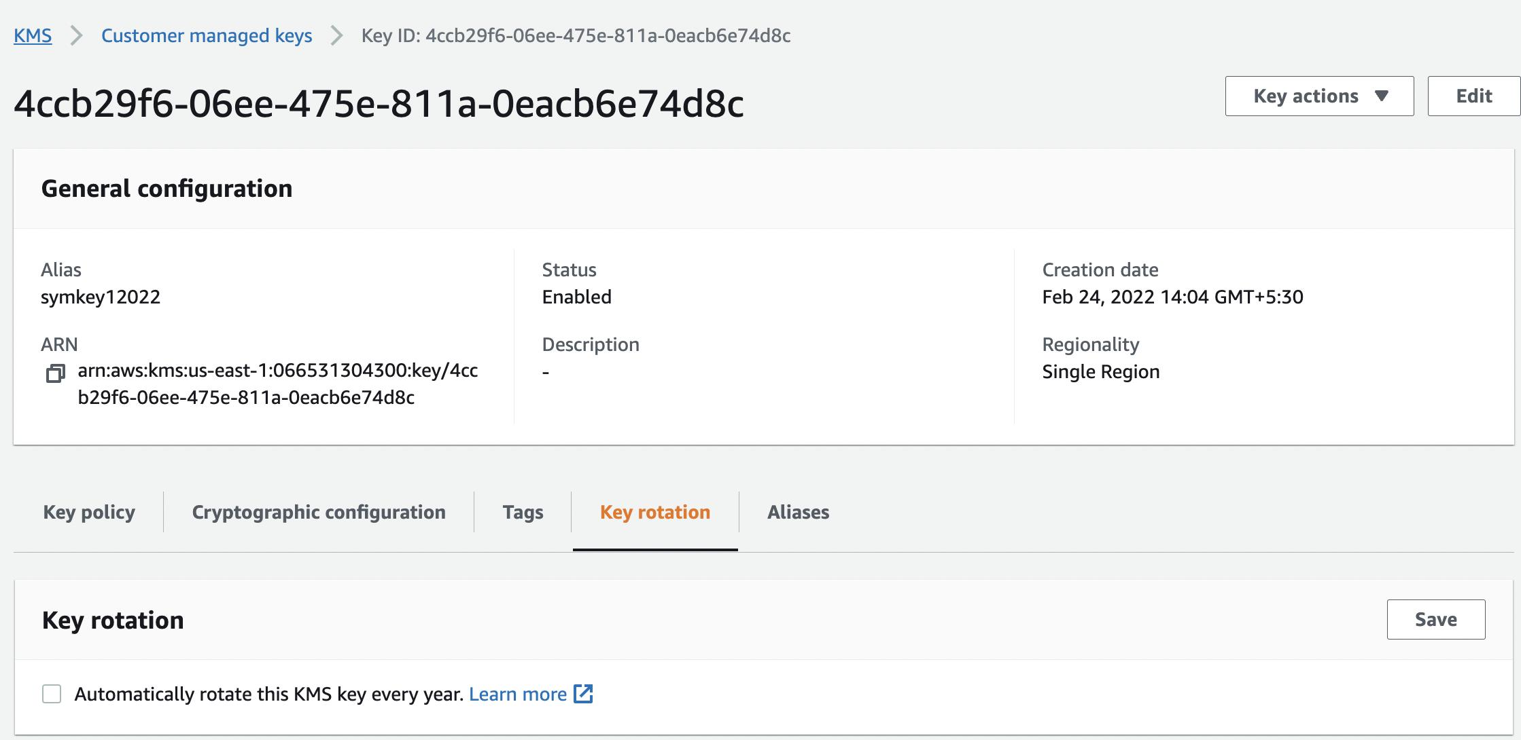
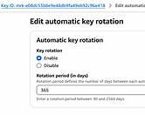
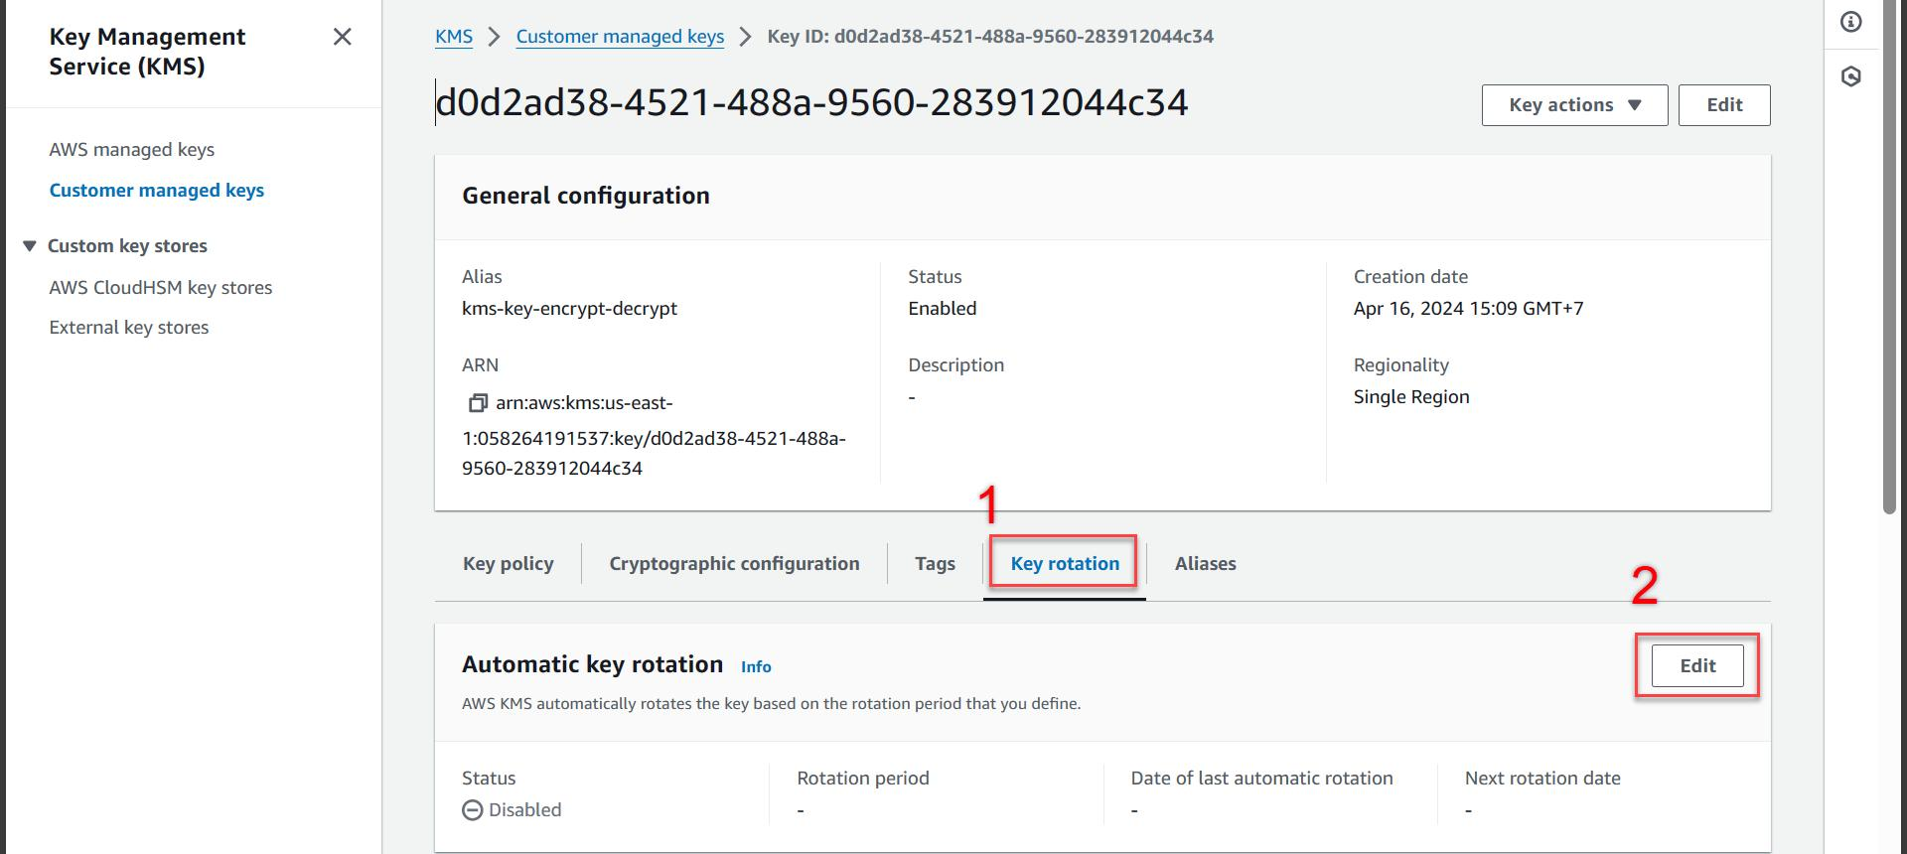
After opening Customer Managed Keys → FoodieAppKey → Key Rotation, you should see Automatic key rotation enabled. AWS documents how to enable this from the console or CLI.

3. Example AWS CLI Commands
Create Alias
aws kms create-alias \
--alias-name alias/FoodieAppKey \
--target-key-id <Key-ID>

Enable Key Rotation
aws kms enable-key-rotation \
--key-id alias/FoodieAppKey
Check status:
aws kms get-key-rotation-status \
--key-id alias/FoodieAppKey
Example output:
{
"KeyRotationEnabled": true
}
AWS also supports checking the next rotation date and rotation period for eligible keys.

4. Example DEK Generation
Command
aws kms generate-data-key \
--key-id alias/FoodieAppKey \
--key-spec AES_256
Example output
{
"CiphertextBlob":"AQICAHjqh7S.....",
"Plaintext":"X4kL2bP4cA.....",
"KeyId":"arn:aws:kms:us-east-1:123456789012:key/abcd1234"
}

Sample Encryption
Original Text
OrderID: 12345, Item: Pizza
Encrypted Output (Example)
gAAAAABnX9MJL8Q2mN0L3T8M5R4Y9xvPqA...
Decrypted Output
OrderID: 12345, Item: Pizza

5. Sample Comparison Table
AWS KMS | Azure Key Vault
Manages encryption keys | Manages encryption keys
Supports automatic key rotation | Supports automatic key rotation
Integrates with AWS services | Integrates with Azure services
Uses IAM and Key Policies | Uses Azure RBAC and Access Policies

6. Sample Key Rotation Policy
Flipkart E-Commerce Key Rotation Policy
Purpose
Protect customer information, payment details, and order records using secure encryption keys.
Rotation Frequency
- Rotate encryption keys every 12 months.
- Rotate immediately if a key is suspected to be compromised.
Notification Process
- Notify the security team 30 days before scheduled rotation.
- Send email alerts after successful rotation.
- Send immediate alerts if rotation fails.
Compromised Key Handling
- Disable the compromised key.
- Create a new encryption key.
- Re-encrypt sensitive data.
- Update application configuration.
- Review audit logs.
- Delete the old key only after verification.
Changes I would make
- Rotate production keys every 6 months.
- Enable SMS and email alerts.
- Require multi-factor approval before deleting a key.

Report Format (Example)

AWS KMS Assignment

Task 1
--------
Created Customer Managed Key
Name: FoodieAppKey
Alias: alias/FoodieAppKey
ARN:
arn:aws:kms:us-east-1:123456789012:key/abcd1234-5678-90ef-1234-abcdef567890

Task 2
--------
Enabled Automatic Key Rotation

(Screenshot Here)

Task 3
--------
AWS KMS vs Azure Key Vault Comparison

(Table Here)

Task 4
--------
Generated Data Encryption Key

Original:
OrderID: 12345, Item: Pizza

Encrypted:
gAAAAAB......

Decrypted:
OrderID: 12345, Item: Pizza

Task 5
--------
Key Rotation Policy

(Paste Policy Here)

